**Managing Deployments Using Kubernetes Engine**

experimentLabschedule1 houruniversal_currency_altNo costshow_chartIntermediate

Rate Lab

**GSP053**



**Overview**

Dev Ops practices will regularly make use of multiple deployments to manage application deployment scenarios such as "Continuous deployment", "Blue-Green deployments", "Canary deployments" and more. This lab teaches you how to scale and manage containers so you can accomplish these common scenarios where multiple heterogeneous deployments are being used.

**Objectives**

In this lab, you will learn how to perform the following tasks:

* Use the kubectl tool
* Create deployment yaml files
* Launch, update, and scale deployments
* Update deployments and learn about deployment styles

Prerequisites

To maximize your learning, the following is recommended for this lab:

* You've taken these Google Cloud Skills Boost labs:
  + [Introduction to Docker](https://google.qwiklabs.com/catalog_lab/944)
  + [Hello Node Kubernetes](https://google.qwiklabs.com/catalog_lab/468)
* You have Linux System Administration skills.
* You understand DevOps theory, concepts of continuous deployment.

**Introduction to deployments**

Heterogeneous deployments typically involve connecting two or more distinct infrastructure environments or regions to address a specific technical or operational need. Heterogeneous deployments are called "hybrid", "multi-cloud", or "public-private", depending upon the specifics of the deployment.

For this lab, heterogeneous deployments include those that span regions within a single cloud environment, multiple public cloud environments (multi-cloud), or a combination of on-premises and public cloud environments (hybrid or public-private).

Various business and technical challenges can arise in deployments that are limited to a single environment or region:

* **Maxed out resources**: In any single environment, particularly in on-premises environments, you might not have the compute, networking, and storage resources to meet your production needs.
* **Limited geographic reach**: Deployments in a single environment require people who are geographically distant from one another to access one deployment. Their traffic might travel around the world to a central location.
* **Limited availability**: Web-scale traffic patterns challenge applications to remain fault-tolerant and resilient.
* **Vendor lock-in**: Vendor-level platform and infrastructure abstractions can prevent you from porting applications.
* **Inflexible resources**: Your resources might be limited to a particular set of compute, storage, or networking offerings.

Heterogeneous deployments can help address these challenges, but they must be architected using programmatic and deterministic processes and procedures. One-off or ad-hoc deployment procedures can cause deployments or processes to be brittle and intolerant of failures. Ad-hoc processes can lose data or drop traffic. Good deployment processes must be repeatable and use proven approaches for managing provisioning, configuration, and maintenance.

Three common scenarios for heterogeneous deployment are:

* multi-cloud deployments
* fronting on-premises data
* continuous integration/continuous delivery (CI/CD) processe

The following exercises practice some common use cases for heterogeneous deployments, along with well-architected approaches using Kubernetes and other infrastructure resources to accomplish them.

**Setup and requirements**

Before you click the Start Lab button

Read these instructions. Labs are timed and you cannot pause them. The timer, which starts when you click **Start Lab**, shows how long Google Cloud resources will be made available to you.

This hands-on lab lets you do the lab activities yourself in a real cloud environment, not in a simulation or demo environment. It does so by giving you new, temporary credentials that you use to sign in and access Google Cloud for the duration of the lab.

To complete this lab, you need:

* Access to a standard internet browser (Chrome browser recommended).

**Note:** Use an Incognito or private browser window to run this lab. This prevents any conflicts between your personal account and the Student account, which may cause extra charges incurred to your personal account.

* Time to complete the lab---remember, once you start, you cannot pause a lab.

**Note:** If you already have your own personal Google Cloud account or project, do not use it for this lab to avoid extra charges to your account.

How to start your lab and sign in to the Google Cloud console

1. Click the **Start Lab** button. If you need to pay for the lab, a pop-up opens for you to select your payment method. On the left is the **Lab Details** panel with the following:
   * The **Open Google Cloud console** button
   * Time remaining
   * The temporary credentials that you must use for this lab
   * Other information, if needed, to step through this lab
2. Click **Open Google Cloud console** (or right-click and select **Open Link in Incognito Window** if you are running the Chrome browser).

The lab spins up resources, and then opens another tab that shows the **Sign in** page.

***Tip:*** Arrange the tabs in separate windows, side-by-side.

**Note:**If you see the **Choose an account** dialog, click **Use Another Account**.

1. If necessary, copy the **Username** below and paste it into the **Sign in** dialog.

student-00-abd642b05961@qwiklabs.net

Copied!

content_copy

You can also find the **Username** in the **Lab Details** panel.

1. Click **Next**.
2. Copy the **Password** below and paste it into the **Welcome** dialog.

oyHpNudXIg0g

Copied!

content_copy

You can also find the **Password** in the **Lab Details** panel.

1. Click **Next**.

**Important:**You must use the credentials the lab provides you. Do not use your Google Cloud account credentials.**Note:**Using your own Google Cloud account for this lab may incur extra charges.

1. Click through the subsequent pages:
   * Accept the terms and conditions.
   * Do not add recovery options or two-factor authentication (because this is a temporary account).
   * Do not sign up for free trials.

After a few moments, the Google Cloud console opens in this tab.

**Note:** To view a menu with a list of Google Cloud products and services, click the **Navigation menu** at the top-left. 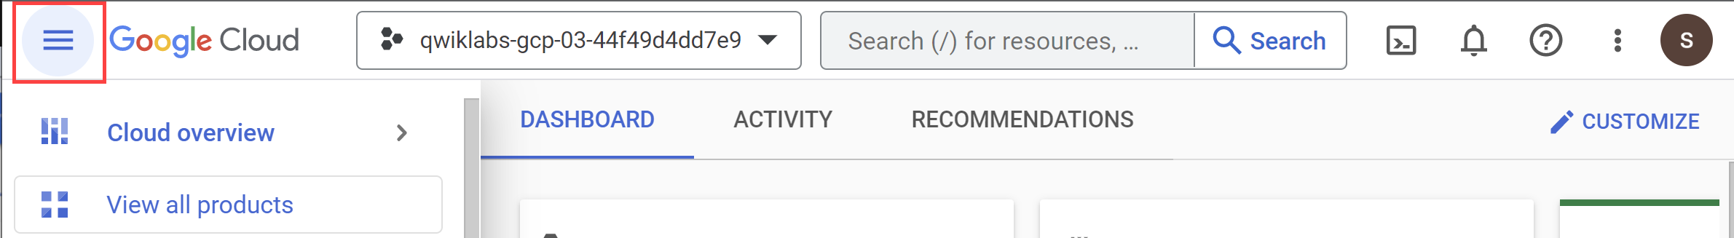

Activate Cloud Shell

Cloud Shell is a virtual machine that is loaded with development tools. It offers a persistent 5GB home directory and runs on the Google Cloud. Cloud Shell provides command-line access to your Google Cloud resources.

1. Click **Activate Cloud Shell** Activate Cloud Shell icon at the top of the Google Cloud console.

When you are connected, you are already authenticated, and the project is set to your **Project_ID**, qwiklabs-gcp-00-a626b61c681e. The output contains a line that declares the **Project_ID** for this session:

Your Cloud Platform project in this session is set to qwiklabs-gcp-00-a626b61c681e

gcloud is the command-line tool for Google Cloud. It comes pre-installed on Cloud Shell and supports tab-completion.

1. (Optional) You can list the active account name with this command:

gcloud auth list

Copied!

content_copy

1. Click **Authorize**.

**Output:**

ACTIVE: *

ACCOUNT: student-00-abd642b05961@qwiklabs.net

To set the active account, run:

$ gcloud config set account `ACCOUNT`

1. (Optional) You can list the project ID with this command:

gcloud config list project

Copied!

content_copy

**Output:**

[core]

project = qwiklabs-gcp-00-a626b61c681e

**Note:**For full documentation of gcloud, in Google Cloud, refer to [the gcloud CLI overview guide](https://cloud.google.com/sdk/gcloud).

**Set the zone**

Set your working Google Cloud zone by running the following command, substituting the local zone as us-east5-a:

gcloud config set compute/zone us-east5-a

Copied!

content_copy

**Get sample code for this lab**

1. Get the sample code for creating and running containers and deployments:

gsutil -m cp -r gs://spls/gsp053/orchestrate-with-kubernetes .

cd orchestrate-with-kubernetes/kubernetes

Copied!

content_copy

1. Create a cluster with 3 nodes (this will take a few minutes to complete):

gcloud container clusters create bootcamp \

--machine-type e2-small \

--num-nodes 3 \

--scopes "https://www.googleapis.com/auth/projecthosting,storage-rw"

Copied!

content_copy

**Task 1. Learn about the deployment object**

To get started, take a look at the deployment object.

1. The explain command in kubectl can tell us about the deployment object:

kubectl explain deployment

Copied!

content_copy

1. You can also see all of the fields using the --recursive option:

kubectl explain deployment --recursive

Copied!

content_copy

1. You can use the explain command as you go through the lab to help you understand the structure of a deployment object and understand what the individual fields do:

kubectl explain deployment.metadata.name

Copied!

content_copy

**Task 2. Create a deployment**

1. Update the deployments/auth.yaml configuration file:

vi deployments/auth.yaml

Copied!

content_copy

1. Start the editor:

i

Copied!

content_copy

1. Change the image in the containers section of the deployment to the following:

...

containers:

- name: auth

image: "kelseyhightower/auth:1.0.0"

...

Copied!

content_copy

1. Save the auth.yaml file: press <Esc> then type:

:wq

Copied!

content_copy

1. Press <Enter>. Now create a simple deployment. Examine the deployment configuration file:

cat deployments/auth.yaml

Copied!

content_copy

Output:

apiVersion: apps/v1

kind: Deployment

metadata:

name: auth

spec:

replicas: 1

selector:

matchLabels:

app: auth

template:

metadata:

labels:

app: auth

track: stable

spec:

containers:

- name: auth

image: "kelseyhightower/auth:1.0.0"

ports:

- name: http

containerPort: 80

- name: health

containerPort: 81

...

Notice how the deployment is creating one replica and it's using version 1.0.0 of the auth container.

When you run the kubectl create command to create the auth deployment, it will make one pod that conforms to the data in the deployment manifest. This means you can scale the number of Pods by changing the number specified in the replicas field.

1. Go ahead and create your deployment object using kubectl create:

kubectl create -f deployments/auth.yaml

Copied!

content_copy

1. Once you have created the deployment, you can verify that it was created:

kubectl get deployments

Copied!

content_copy

1. Once the deployment is created, Kubernetes will create a ReplicaSet for the deployment. You can verify that a ReplicaSet was created for the deployment:

kubectl get replicasets

Copied!

content_copy

You should see a ReplicaSet with a name like auth-xxxxxxx

1. View the Pods that were created as part of the deployment. The single Pod is created by the Kubernetes when the ReplicaSet is created:

kubectl get pods

Copied!

content_copy

It's time to create a service for the auth deployment. You've already seen service manifest files, so the details won't be shared here.

1. Use the kubectl create command to create the auth service:

kubectl create -f services/auth.yaml

Copied!

content_copy

1. Now, do the same thing to create and expose the hello deployment:

kubectl create -f deployments/hello.yaml

kubectl create -f services/hello.yaml

Copied!

content_copy

1. And one more time to create and expose the frontend deployment:

kubectl create secret generic tls-certs --from-file tls/

kubectl create configmap nginx-frontend-conf --from-file=nginx/frontend.conf

kubectl create -f deployments/frontend.yaml

kubectl create -f services/frontend.yaml

Copied!

content_copy

**Note:** You created a ConfigMap for the frontend.

1. Interact with the frontend by grabbing its external IP and then curling to it:

kubectl get services frontend

Copied!

content_copy

**Note:**It may take a few seconds before the External-IP field is populated for your service. This is normal. Just re-run the above command every few seconds until the field is populated.

curl -ks https://<EXTERNAL-IP>

Copied!

content_copy

And you get the hello response back.

1. You can also use the output templating feature of kubectl to use curl as a one-liner:

curl -ks https://`kubectl get svc frontend -o=jsonpath="{.status.loadBalancer.ingress[0].ip}"`

Copied!

content_copy

Test completed task

Click **Check my progress** below to check your lab progress. If you successfully created Kubernetes cluster and Auth, Hello and Frontend deployments, you'll see an assessment score.

Create a Kubernetes cluster and deployments (Auth, Hello, and Frontend)

Check my progress

Scale a deployment

Now that you have a deployment created, you can scale it. Do this by updating the spec.replicas field.

1. Look at an explanation of this field using the kubectl explain command again:

kubectl explain deployment.spec.replicas

Copied!

content_copy

1. The replicas field can be most easily updated using the kubectl scale command:

kubectl scale deployment hello --replicas=5

Copied!

content_copy

**Note:** It may take a minute or so for all the new pods to start up.

After the deployment is updated, Kubernetes will automatically update the associated ReplicaSet and start new Pods to make the total number of Pods equal 5.

1. Verify that there are now 5 hello Pods running:

kubectl get pods | grep hello- | wc -l

Copied!

content_copy

1. Now scale back the application:

kubectl scale deployment hello --replicas=3

Copied!

content_copy

1. Again, verify that you have the correct number of Pods:

kubectl get pods | grep hello- | wc -l

Copied!

content_copy

Now you know about Kubernetes deployments and how to manage & scale a group of Pods.

**Task 3. Rolling update**

Deployments support updating images to a new version through a rolling update mechanism. When a deployment is updated with a new version, it creates a new ReplicaSet and slowly increases the number of replicas in the new ReplicaSet as it decreases the replicas in the old ReplicaSet.

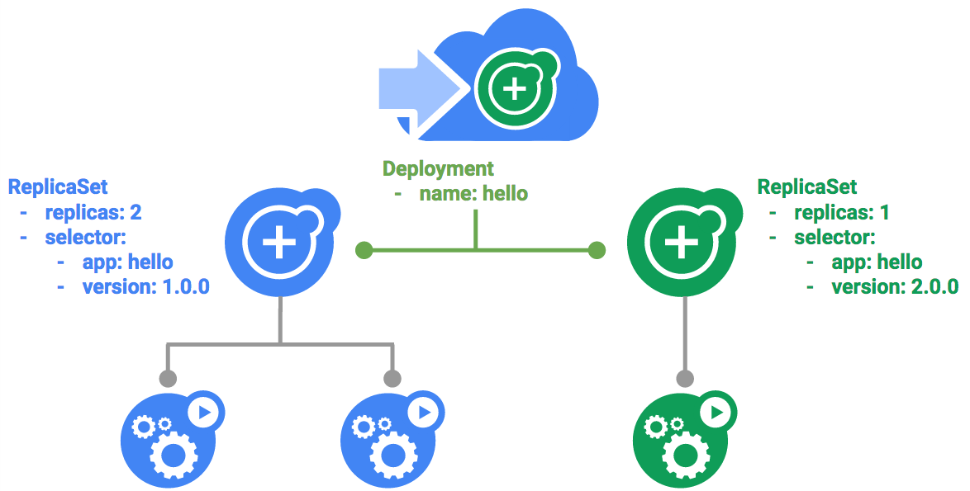

Trigger a rolling update

1. To update your deployment, run the following command:

kubectl edit deployment hello

Copied!

content_copy

1. Change the image in the containers section of the deployment to the following:

...

containers:

image: kelseyhightower/hello:2.0.0

...

Copied!

content_copy

1. **Save** and **exit**.

The updated deployment will be saved to your cluster and Kubernetes will begin a rolling update.

1. See the new ReplicaSet that Kubernetes creates.:

kubectl get replicaset

Copied!

content_copy

1. You can also see a new entry in the rollout history:

kubectl rollout history deployment/hello

Copied!

content_copy

Pause a rolling update

If you detect problems with a running rollout, pause it to stop the update.

1. Run the following to pause the rollout:

kubectl rollout pause deployment/hello

Copied!

content_copy

1. Verify the current state of the rollout:

kubectl rollout status deployment/hello

Copied!

content_copy

1. You can also verify this on the Pods directly:

kubectl get pods -o jsonpath --template='{range .items[*]}{.metadata.name}{"\t"}{"\t"}{.spec.containers[0].image}{"\n"}{end}'

Copied!

content_copy

Resume a rolling update

The rollout is paused which means that some pods are at the new version and some pods are at the older version.

1. Continue the rollout using the resume command:

kubectl rollout resume deployment/hello

Copied!

content_copy

1. When the rollout is complete, you should see the following when running the status command:

kubectl rollout status deployment/hello

Copied!

content_copy

Output:

deployment "hello" successfully rolled out

Roll back an update

Assume that a bug was detected in your new version. Since the new version is presumed to have problems, any users connected to the new Pods will experience those issues.

You will want to roll back to the previous version so you can investigate and then release a version that is fixed properly.

1. Use the rollout command to roll back to the previous version:

kubectl rollout undo deployment/hello

Copied!

content_copy

1. Verify the roll back in the history:

kubectl rollout history deployment/hello

Copied!

content_copy

1. Finally, verify that all the Pods have rolled back to their previous versions:

kubectl get pods -o jsonpath --template='{range .items[*]}{.metadata.name}{"\t"}{"\t"}{.spec.containers[0].image}{"\n"}{end}'

Copied!

content_copy

Great! You learned how to do a rolling update for Kubernetes deployments and how to update applications without downtime.

**Task 4. Canary deployments**

When you want to test a new deployment in production with a subset of your users, use a canary deployment. Canary deployments allow you to release a change to a small subset of your users to mitigate risk associated with new releases.

Create a canary deployment

A canary deployment consists of a separate deployment with your new version and a service that targets both your normal, stable deployment as well as your canary deployment.

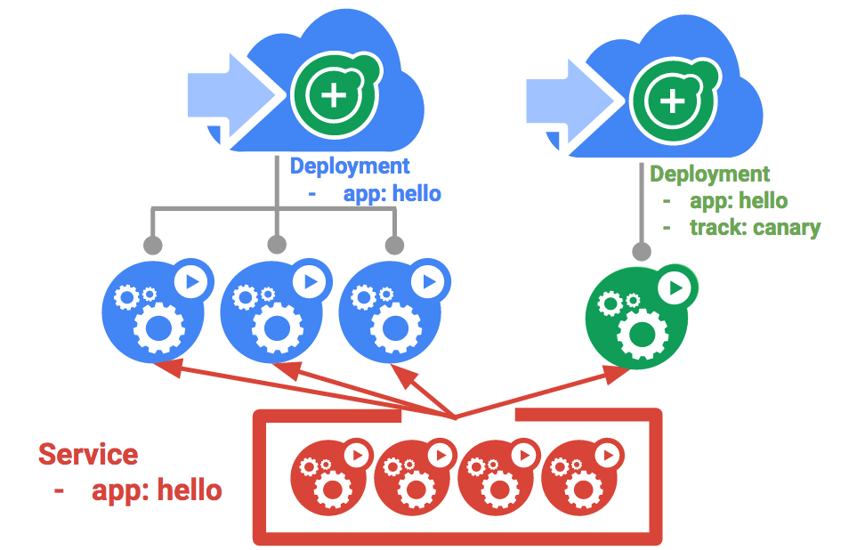

1. First, create a new canary deployment for the new version:

cat deployments/hello-canary.yaml

Copied!

content_copy

Output:

apiVersion: apps/v1

kind: Deployment

metadata:

name: hello-canary

spec:

replicas: 1

selector:

matchLabels:

app: hello

template:

metadata:

labels:

app: hello

track: canary

# Use ver 2.0.0 so it matches version on service selector

version: 2.0.0

spec:

containers:

- name: hello

image: kelseyhightower/hello:2.0.0

ports:

- name: http

containerPort: 80

- name: health

containerPort: 81

...

1. Now create the canary deployment:

kubectl create -f deployments/hello-canary.yaml

Copied!

content_copy

1. After the canary deployment is created, you should have two deployments, hello and hello-canary. Verify it with this kubectl command:

kubectl get deployments

Copied!

content_copy

On the hello service, the app:hello selector will match pods in **both** the prod deployment and canary deployment. However, because the canary deployment has a fewer number of pods, it will be visible to fewer users.

Verify the canary deployment

1. You can verify the hello version being served by the request:

curl -ks https://`kubectl get svc frontend -o=jsonpath="{.status.loadBalancer.ingress[0].ip}"`/version

Copied!

content_copy

1. Run this several times and you should see that some of the requests are served by hello 1.0.0 and a small subset (1/4 = 25%) are served by 2.0.0.

**Test completed task**

Click **Check my progress** below to check your lab progress. If you successfully created Canary deployment, you'll see an assessment score.

Canary Deployment

Check my progress

Canary deployments in production - session affinity

In this lab, each request sent to the Nginx service had a chance to be served by the canary deployment. But what if you wanted to ensure that a user didn't get served by the canary deployment? A use case could be that the UI for an application changed, and you don't want to confuse the user. In a case like this, you want the user to "stick" to one deployment or the other.

You can do this by creating a service with session affinity. This way the same user will always be served from the same version. In the example below, the service is the same as before, but a new sessionAffinity field has been added, and set to ClientIP. All clients with the same IP address will have their requests sent to the same version of the hello application.

kind: Service

apiVersion: v1

metadata:

name: "hello"

spec:

sessionAffinity: ClientIP

selector:

app: "hello"

ports:

- protocol: "TCP"

port: 80

targetPort: 80

Due to it being difficult to set up an environment to test this, you don't need to here, but you may want to use sessionAffinity for canary deployments in production.

**Task 5. Blue-green deployments**

Rolling updates are ideal because they allow you to deploy an application slowly with minimal overhead, minimal performance impact, and minimal downtime. There are instances where it is beneficial to modify the load balancers to point to that new version only after it has been fully deployed. In this case, blue-green deployments are the way to go.

Kubernetes achieves this by creating two separate deployments; one for the old "blue" version and one for the new "green" version. Use your existing hello deployment for the "blue" version. The deployments will be accessed via a service which will act as the router. Once the new "green" version is up and running, you'll switch over to using that version by updating the service.

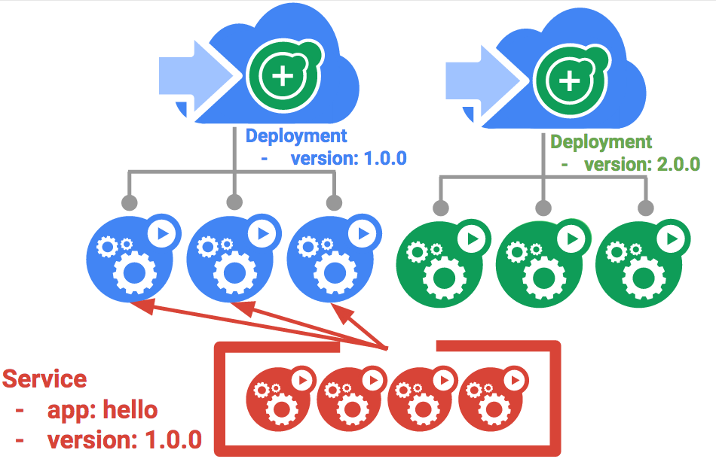

**Note:**A major downside of blue-green deployments is that you will need to have at least 2x the resources in your cluster necessary to host your application. Make sure you have enough resources in your cluster before deploying both versions of the application at once.

The service

Use the existing hello service, but update it so that it has a selector app:hello, version: 1.0.0. The selector will match the existing "blue" deployment. But it will not match the "green" deployment because it will use a different version.

* First update the service:

kubectl apply -f services/hello-blue.yaml

Copied!

content_copy

**Note:**Ignore the warning that says resource service/hello is missing as this is patched automatically.

Updating using Blue-Green deployment

In order to support a blue-green deployment style, you will create a new "green" deployment for the new version. The green deployment updates the version label and the image path.

apiVersion: apps/v1

kind: Deployment

metadata:

name: hello-green

spec:

replicas: 3

selector:

matchLabels:

app: hello

template:

metadata:

labels:

app: hello

track: stable

version: 2.0.0

spec:

containers:

- name: hello

image: kelseyhightower/hello:2.0.0

ports:

- name: http

containerPort: 80

- name: health

containerPort: 81

resources:

limits:

cpu: 0.2

memory: 10Mi

livenessProbe:

httpGet:

path: /healthz

port: 81

scheme: HTTP

initialDelaySeconds: 5

periodSeconds: 15

timeoutSeconds: 5

readinessProbe:

httpGet:

path: /readiness

port: 81

scheme: HTTP

initialDelaySeconds: 5

timeoutSeconds: 1

1. Create the green deployment:

kubectl create -f deployments/hello-green.yaml

Copied!

content_copy

1. Once you have a green deployment and it has started up properly, verify that the current version of 1.0.0 is still being used:

curl -ks https://`kubectl get svc frontend -o=jsonpath="{.status.loadBalancer.ingress[0].ip}"`/version

Copied!

content_copy

1. Now, update the service to point to the new version:

kubectl apply -f services/hello-green.yaml

Copied!

content_copy

1. When the service is updated, the "green" deployment will be used immediately. You can now verify that the new version is always being used:

curl -ks https://`kubectl get svc frontend -o=jsonpath="{.status.loadBalancer.ingress[0].ip}"`/version

Copied!

content_copy

Blue-Green rollback

If necessary, you can roll back to the old version in the same way.

1. While the "blue" deployment is still running, just update the service back to the old version:

kubectl apply -f services/hello-blue.yaml

Copied!

content_copy

1. Once you have updated the service, your rollback will have been successful. Again, verify that the right version is now being used:

curl -ks https://`kubectl get svc frontend -o=jsonpath="{.status.loadBalancer.ingress[0].ip}"`/version

Copied!

content_copy

You did it! You learned about blue-green deployments and how to deploy updates to applications that need to switch versions all at once.

**Congratulations!**

You've had the opportunity to work more with the kubectl command-line tool, and many styles of deployment configurations set up in YAML files to launch, update, and scale your deployments. With this foundation of practice you should feel comfortable applying these skills to your own DevOps practice.

Next steps / Learn more

* [Deployment Patterns with Kubernetes](https://cloud.google.com/solutions/heterogeneous-deployment-patterns-with-kubernetes).
* [DevOps Solutions and DevOps Guides](https://cloud.google.com/solutions/devops/) in the Google Cloud documentation.
* On the Kubernetes website, connect with the [Kubernetes Community](https://kubernetes.io/community/)!

Google Cloud training and certification

...helps you make the most of Google Cloud technologies. [Our classes](https://cloud.google.com/training/courses) include technical skills and best practices to help you get up to speed quickly and continue your learning journey. We offer fundamental to advanced level training, with on-demand, live, and virtual options to suit your busy schedule. [Certifications](https://cloud.google.com/certification/) help you validate and prove your skill and expertise in Google Cloud technologies.

**Manual last updated April 2, 2024**

**Lab last tested August 14, 2023**

Copyright 2024 Google LLC All rights reserved. Google and the Google logo are trademarks of Google LLC. All other company and product names may be trademarks of the respective companies with which they are associated.

navigate_beforePrevious

[Nextnavigate_next](https://www.cloudskillsboost.google/course_templates/783/labs/408509)